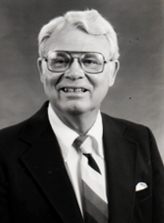

Herb J. Redding
Head Football Coach
Gibsonburg Exempted Village Schools

