HERB REDDING
NOMINATION FOR THE
OHIO HIGH SCHOOL FOOTBALL ASSOICATION
HALL OF FAME

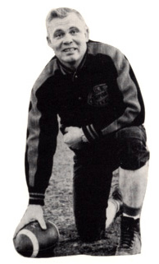

Letters of Recommendation
Collected from the different eras of Coach Redding’s
tenure as Head Football Coach
at
Gibsonburg High School

